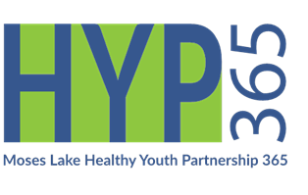Moses Lake Prevention

Received email approval

Receipt and Purchase Requisition copy to Manager and Finance

Budget Spending Tracker entry

Minerva Entry

A-19 confirmation

*Reimbursed

Item/s received

***Date:*** Click here to enter a date. ***Receipt Date:*** Click here to enter a date.

***Vendor***: Click here to enter text.

***Description*** Click here to enter text.

***A-19/Minerva Title:*** Click here to enter text.

**Implementation Month: Form of Payment**

January 2020

February 2020

March 2020

April 2020

May 2020

June 2020

July 2020

August 2020

September 2020

October 2020

November 2020

December 2020

VISA

Invoice (paid)

Invoice (needs paid)

Other: Click here to enter text.

**Program: Charge Account:**

Community Prevention Education 22.1.1

Public Awareness Campaign 22.1.1

PAX Good Behavior Game 22.2.1

Strengthening Families Program 22.2.1

Positive Action 22.2.1

General Coalition 22.5.1

Environmental Policy 22.6.1

Training 22.7.1

SABG

DMA

PFS

Grant County Health District (YMPEP)

Other: Click here to enter text.

**$** Click here to enter text.

Requested by: _________________

Supervisor Signature: Date: ________________