Tobacco and Vapor 21
Community Education Packet

[Insert Incident Name]
WHAT’S INCLUDED

- Background
- Talking Points
- Press Release
- Email Blast
- Social Media
- Graphics
- Q&A
- Cessation Resources

1 | BACKGROUND

Engrossed House Bill 1074 was signed into law in 2019. The law goes into effect on January 1, 2020, when it will become illegal to sell tobacco or vapor products to anyone under 21.

The Washington State Department of Health will educate and inform the general public about the new law through social and earned media, and regular updates to the Tobacco and Vapor Product Prevention and Control Program (TVPPCP) webpages, which will serve as a navigation portal to connect the public with resources at the federal, state, local, and community level.

For more information from the Department of Health on Tobacco and Vapor 21, cessation tools, and other helpful resources (including a YouTube message from Secretary of Health John Wiesman – which we encourage you to share!), visit www.doh.wa.gov/tobacco-and-vapor-21.

For more information from the Liquor and Cannabis Board on the legal implications of Tobacco and Vapor 21 (including for retailers and clerks), visit www.lcb.wa.gov/tobacco-vapor-21.

2 | KEY TALKING POINTS

- Beginning January 1, 2020, it will be illegal to sell tobacco or vapor products to anyone under 21.
- Washington kids and teens are experiencing a vaping epidemic. In 2018, one in five 10th graders and one in three 12th graders reported using vapor products (Healthy Youth Survey).
- Individuals under 21 are particularly vulnerable to the effects of nicotine addiction.
- Most people who smoke begin smoking before age 21—this law will help protect young people from the health consequences of using tobacco, which remains the leading cause of preventable death in Washington.
- Washingtonians can get free help to quit smoking or vaping by contacting the Washington State Tobacco Quitline at 1-800-QUIT-NOW or by accessing a smartphone app at www.doh.wa.gov/quit.

3 | PRESS RELEASE

For immediate release: month, day, 2019
Contact:

[ORGANIZATION] Joins Statewide Effort to Educate Public
About Tobacco and Vapor 21 Legislation

As part of its work to protect kids and teens from smoking and vaping, [ORGANIZATION] is reminding the public that Engrossed House Bill 1074 goes into effect on January 1, 2020, when it will become illegal to sell tobacco and vapor products to anyone under 21.
“Young people in Washington are in the middle of a vaping epidemic,” said [ORGANIZATION REPRESENTATIVE]. “Raising the age of sale for tobacco and vapor products to 21 will reduce the number of kids who develop a lifelong addiction to nicotine and save thousands of lives.”
In 2018, one in five Washington 10th graders and one in three 12th graders reported using vapor products (Healthy Youth Survey) [insert local data if desired]. Nearly all people who smoke begin smoking before age 21—while their brains are particularly vulnerable to the effects of nicotine—and most young people get tobacco and nicotine products from peers in their social networks who can legally buy them. Kids who vape are at an increased risk of initiating cigarette smoking; raising the legal age of sale will help protect young people by preventing them from getting products tobacco and vapor products from 18, 19, or 20 year olds.

Including Washington State, tobacco and vapor 21 is currently the law – or is due to go into effect – in 18 states as well as D.C. and Guam.

Tobacco kills more than 8,000 Washingtonians each year. Washingtonians can get free help to quit smoking or vaping by contacting the Washington State Tobacco Quitline at 1-800-QUIT-NOW or by accessing a smartphone app at www.doh.wa.gov/quit. Parents and schools can find more information about how to address youth vaping at www.youthnow.me/schools.

###

4 | EMAIL BLAST

Earlier this month, [ORGANIZATION] announced it was joining the statewide effort to remind the public that Engrossed House Bill 1074 goes into effect on January 1, 2020, when it will become illegal to sell tobacco and vapor products to anyone under 21.
In 2018, one in five Washington 10th graders and one in three 12th graders reported using vapor products (Healthy Youth Survey) [insert local data if desired]. Nearly all people who smoke begin smoking before age 21—while their brains are particularly vulnerable to the effects of nicotine—and most young people get tobacco and nicotine products from peers in their social networks who can legally buy them. Kids who vape are at an increased risk of initiating cigarette smoking; raising the legal age of sale will help protect young people by preventing them from getting products tobacco and vapor products from 18, 19, or 20 year olds.

Including Washington State, tobacco and vapor 21 is currently the law – or is due to go into effect – in 18 states as well as D.C. and Guam.

Tobacco kills more than 8,000 Washingtonians each year. Washingtonians can get free help to quit smoking or vaping by contacting the Washington State Tobacco Quitline at 1-800-QUIT-NOW or by accessing a smartphone app at www.doh.wa.gov/quit. Parents and schools can find more information about how to address youth vaping at www.youthnow.me/schools.

5 | SOCIAL MEDIA

HASHTAGS:
#Washington21
#TV21WA
#TV21
TWITTER:
- On Jan. 1, 2020, it will become illegal to sell tobacco and vapor products to anyone under 21. Studies show that most people who haven’t started smoking by 21 will never start. #Washington21 #TV21WA #TV21 [IMAGE “TV21 SIGN”] [ROOM TO ADD A LINK]
- We are joining the statewide effort to let people know about a NEW law: on January 1, 2020, it will become illegal to sell tobacco and vapor products to anyone under 21. #Washington21 #TV21WA #TV21 [IMAGE “TV21 SIMPLE MESSAGE”] [ROOM TO ADD A LINK]
- Young people in the nation are in the middle of a vaping epidemic. In WA state it will be illegal to sell tobacco and vapor products to anyone under 21 starting Jan. 1, 2020. This will protect kids from developing a lifelong addiction to nicotine, saving thousands of lives. #Washington21 #TV21WA #TV21 [IMAGE “TV21 SIGN”]
- In 2018, 1/5 high school sophomores in WA reported they’ve vaped. For seniors that rate was 1/3. To combat this epidemic & protect our youth, on Jan. 1, 2020 it will become illegal to sell tobacco & vapor products to anyone under 21 in WA. #Washington21 #TV21WA #TV21 [IMAGE “TV21 SIGN”]
- You can get free help to quit smoking or vaping by contacting the WA State Tobacco Quitline at 1-800-QUIT-NOW. Or download an app for your phone at www.doh.wa.gov/quit. #Washington21 #TV21WA #TV21

- Young people under the age of 21 are particularly vulnerable to the effects of nicotine addiction. Talk to the youth in your life about vaping and smoking. Parents and schools can learn how to address youth vaping at www.youthnow.me/schools #Washington21 #TV21WA #TV21

FACEBOOK:
- [IMAGE “TV21 SIGN”]
We are joining the statewide effort to let you know about a NEW law—on January 1, 2020, it will become illegal to sell tobacco and vapor products to anyone under 21 in WA. #Washington21
[LINK TO YOUR ORGANIZATION’S NEWS RELEASE OR WEBPAGE.]
- [IMAGE “TV21 SIMPLE MESSAGE”]
On Jan. 1, 2020, it will become illegal in Washington state to sell tobacco and vapor products to anyone under 21. Get free help to quit smoking or vaping by calling the Washington State Tobacco Quitline at 1-800-QUIT-NOW or by downloading an app for your phone at www.doh.wa.gov/quit. #Washington21
- [IMAGE “TV21 SIGN”]
Young people under the age of 21 are particularly vulnerable to the effects of nicotine addiction. Talk to the youth in your life about vaping and smoking. Parents and schools can learn how to address youth vaping at www.youthnow.me/schools. #Washington21
(We also encourage you to pull language from the Twitter messages.)

6 | GRAPHICS

“TV21 SIGN”

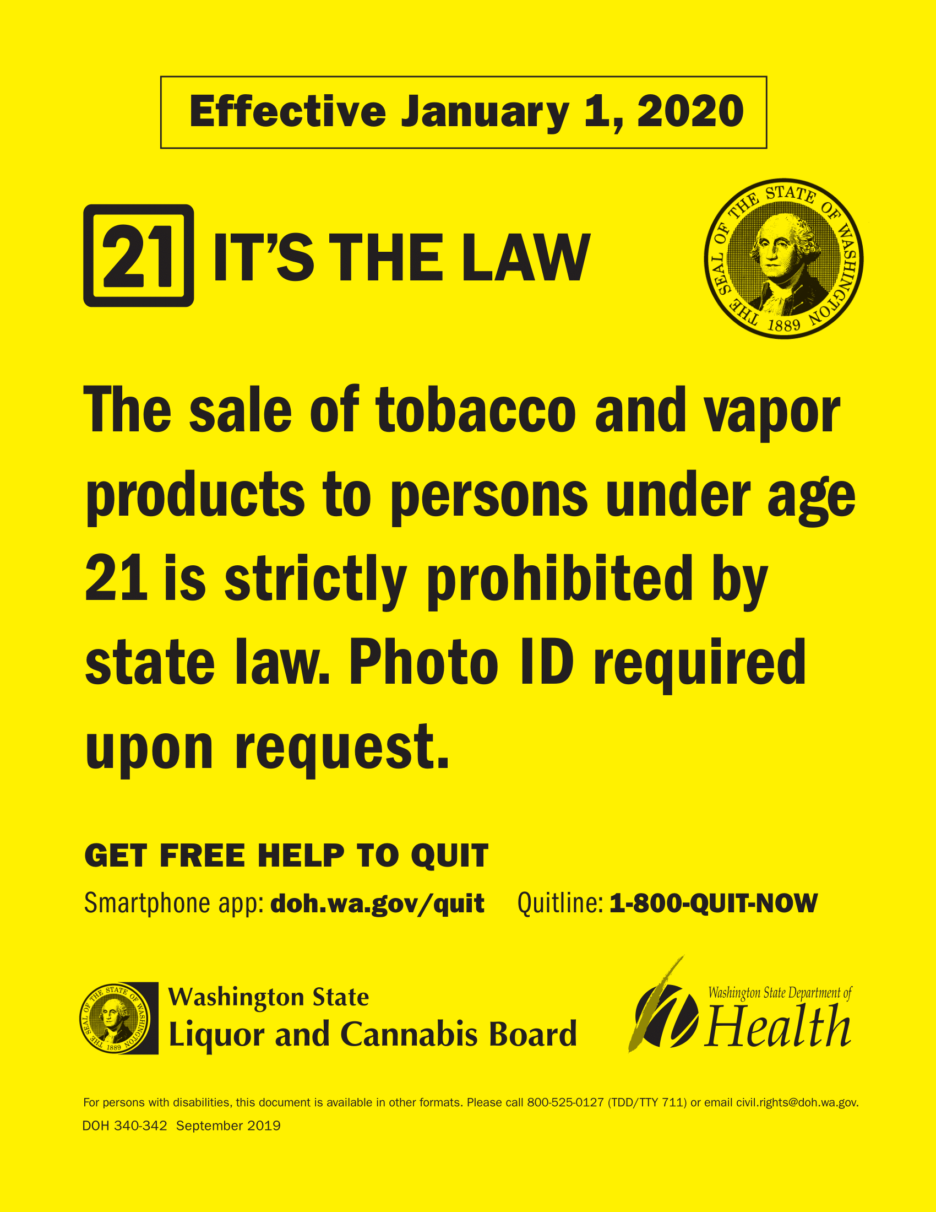

“TV21 SIMPLE MESSAGE”
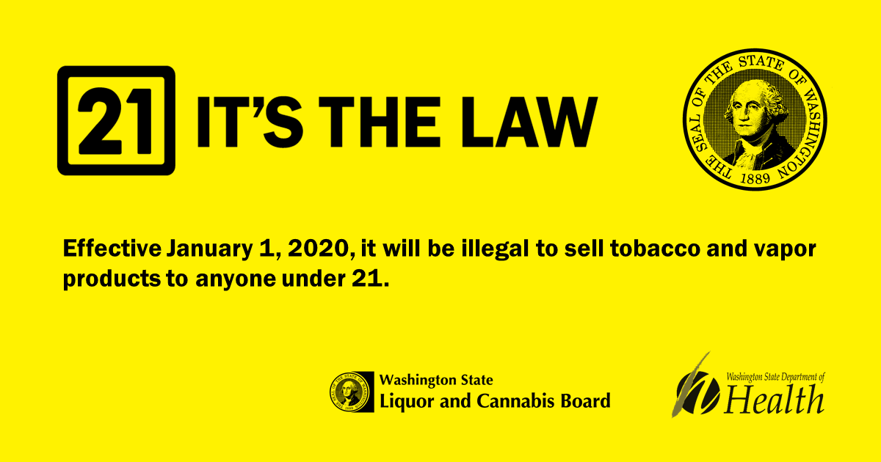

7 | Q&A

[A more concise FAQ is available here; the below Q&A includes more robust background information to help you formulate answers from your stakeholders]

Q: What is Tobacco and Vapor 21 in Washington?
- The law will make it illegal to sell tobacco and vapor products to anyone under 21; it goes into effect January 1, 2020.
- Most people who smoke begin before the age of 18, and most kids get access to tobacco and vapor products from social sources who are 18, 19, and 20. By eliminating social sources for initiation, tobacco and vapor 21 will help prevent the next generation from becoming addicted to nicotine.
- This is a promising strategy to prevent young people from smoking, vaping, and using other tobacco or nicotine products. It complements other policies such as our very comprehensive state law banning smoking in public places, the state vapor product law, and the state’s high tobacco taxes.
Q: Why is tobacco and vapor 21 important?
- More than 8,000 Washingtonians die each year due to tobacco use. We have known for decades that smoking increases the chance of developing lung cancer, dying from pulmonary disease, and having a heart attack or stroke. Washington’s annual health care cost of smoking-related illness is $2.8 billion.
- Among Washington high school seniors:
  - 30% vape
  - 8% smoke cigarettes
  - 7% smoke cigars
  - 4% use smokeless tobacco
- A March 2015 report by the Institute of Medicine, one of the most prestigious scientific authorities in the United States, strongly concluded tobacco and vapor 21 will likely prevent or delay initiation of tobacco use by adolescents and young adults including a projected:
  - 25% reduction in initiation
  - 12% reduction in prevalence
  - 11% reduction in smoking-attributable deaths

Q: How would tobacco and vapor 21 impact the epidemic of vaping in middle and high schools?
- We know most 15- to 17-year-olds get their cigarettes and vapor products from social sources—friends, older siblings, and coworkers who are 18, 19, or 20 years old and can legally purchase.
- Making it illegal to sell tobacco and vapor products to anyone under 21 is key to cutting off those social sources, including social sources in schools—their fellow students. This is important in that tobacco and vape use are learned and socially mediated behaviors.
- Many of our kids believe or are led to believe that vaping is a social norm among their peers. When they see vaping in the schools, this perception is reinforced.
- TV21 will help middle and high schools by creating an environment that encourages and facilitates social norms where tobacco and vape use are not attractive, pervasive or socially acceptable.
Q: What is JUUL? What is vaping? What’s the difference?
- JUUL is a type of vapor product that has become increasingly popular among kids and teens. It represents over 70% of the vapor product market. It may be more at this point in time.
- Every “pod” (which holds the e-liquid) contains approximately the same amount of nicotine as an entire pack of cigarettes.
- The e-liquids come in flavors such as mango, fruit, cucumber, mint, and crème.
- JUUL and other pod-based vapor products also use nicotine salts rather than freebase nicotine, which has a lower Ph level and is a lot smoother to the user. Therefore, you not only get a stronger hit of nicotine, but it’s easier to inhale.
- JUUL resembles a USB-drive and can be charged in a USB port, including a laptop.
- JUULing is vaping. However, some young people are referring to using their JUUL as “juuling” rather than vaping.
  - There was a study done by the Truth Initiative in November 2017 that showed 25% of young people referred to vaping as “JUULing”.
Q: Are vapor products safe, or at least safer than smoking combustible cigarettes?
- We don’t know – there has not been enough time to assess long-term health effects since vapor products came to market, and there is not enough evidence demonstrating that they’re good for quitting. Unlike the seven medications that the FDA has approved for smoking cessation, the FDA has not approved any vapor products as smoking cessation devices.
- We do know that the CDC opened an investigation into lung illness among people who use vapor products in the summer of 2019.
- Vapor products do not emit water vapor – they emit an aerosol with harmful and potentially harmful chemicals, like nicotine.
- Vapor products have the potential to benefit adults who smoke and are not pregnant if used as a complete substitute for regular cigarettes and other smoked tobacco products. In other words, vapor products are probably safer for adults who smoke, but that does not mean they are safe.
- Nicotine is highly addictive, and nicotine addiction isn’t good for anyone. Young people – whose brains are not finished developing until age 25 – are especially harmed by nicotine. Young people who use vapor products are more likely to become smoke cigarettes in the future.

Q: How does nicotine affect young people?
- Because brain development continues until about age 25, adolescents are more susceptible to both the addictiveness and harmfulness of nicotine.
- Nicotine changes adolescents’ brain cell activity in the parts of the brain responsible for attention, learning, and memory.
- It can also worsen:
  - anxiety
  - mood swings
  - irritability
  - impulsivity
- While some of these behaviors can be just adolescent phases, nicotine-induced changes to the brain during adolescence can be permanent.
- Nicotine’s harm can lead to long-term effects on the ability to make decisions and can also leave teens with an increased risk of addiction to other substances.

Q: What are the health effects of secondhand exposure to aerosol from vapor products?
- There are no long-term studies yet on vapor products, so it will take decades to understand the long-term health effects of exposure to vapor product aerosol (as it did with regular tobacco products).
- Aerosol contains harmful and potentially harmful chemicals, including nicotine, as well as particulate matter.
- There is moderate evidence that secondhand exposure to nicotine and particulates is lower from vapor products compared with combustible tobacco cigarettes.

Q: What else do I need to know? Where can I find more information?
- Young adults 18-20 years of age will not face penalties for purchase, possession, or use.
- Young people under 18 years of age will continue to face penalties for purchase, possession, or use.
- More information on the legal implications of tobacco and vapor 21 (including for tobacco and vapor product retailers) will be available here: www.lcb.wa.gov/tobacco-vapor-21
- Find more information on Washington’s 2019 vapor product tax here.

8 | CESSATION RESOURCES

ADULTS
- Washington State Tobacco Quitline: 1-800-QUIT-NOW or visit www.quitline.com
- Smartphone app: www.doh.wa.gov/quit
- Support for parents and schools dealing with youth vaping: https://www.youthnow.me/schools
- DOH Tobacco and Vapor Product Prevention and Control Program Website: https://www.doh.wa.gov/YouandYourFamily/Tobacco

YOUTH
- Washington State Tobacco Quitline (Ages 13-17): 1-800-QUIT-NOW
- Smartphone app: www.doh.wa.gov/quit
- Text: “DITCHJUUL” to 887-09

