Teen Health Hub WA
Example Social Media Posts for Partners

Thank you for helping to spread the word about DOH’s new Teen Health Hub WA! Feel free to tailor these example posts for your audiences.
Have questions or feedback? Please contact Adolescent Health Consultant Alexis Bates.

Captions
Facebook/Linked In
Do you know a young person who needs compassionate health information? We do, too. We collaborated with Washington teens and young adults to create the new Teen Health Hub WA webpage. It has trustworthy answers to young people's important health questions. Credible, compassionate, and here when you need it. Check out Teen Health Hub WA www.doh.wa.gov/teenhealthhub
#teenhealthhubwa

Young people have questions about their health, relationships, birth control, finding mental health support, and navigating health care – Teen Health Hub WA can help them find the answers. We collaborated with Washinton teens and young adults to create the new Teen Health Hub WA webpage. It has trustworthy answers to young people's important health questions Share the link with the young people in your life! Credible, compassionate, and here when you need it. Check out Teen Health Hub WA www.doh.wa.gov/teenhealthhub
#teenhealthhubwa

Instagram/Twitter(X)
Did you know teens as young as 13 can seek mental health services on their own? For more health-related information for young people, check out Teen Health Hub WA. It’s a new DOH webpage created (sparkle emoji)with (sparkle emoji) and (sparkle emoji) for (sparkle emoji) young people to find answers to their important health questions. Credible, compassionate, and here when you need it. Check out Teen Health Hub WA: www.doh.wa.gov/teenhealthhub
#teenhealthhubwa

Looking for accurate and reliable information about sexual health? Check out Teen Health Hub WA. It’s a new DOH webpage created with and for young people to find answers to their important health questions. Credible, compassionate, and here when you need it. Check out Teen Health Hub WA www.doh.wa.gov/teenhealthhub
#teenhealthhubwa

Images
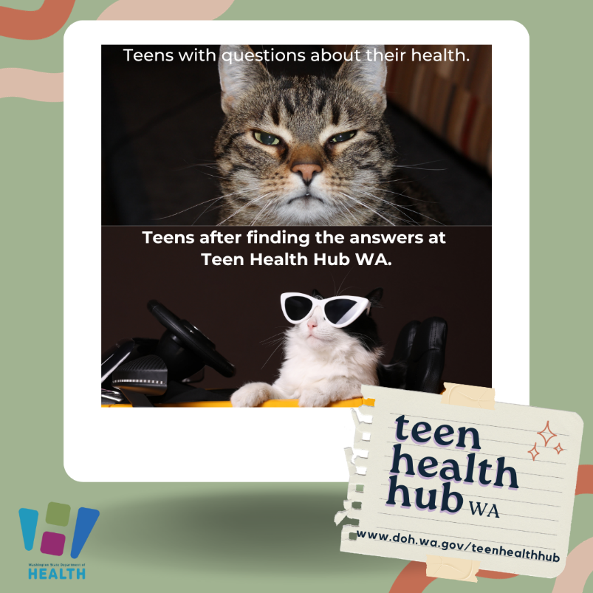 | 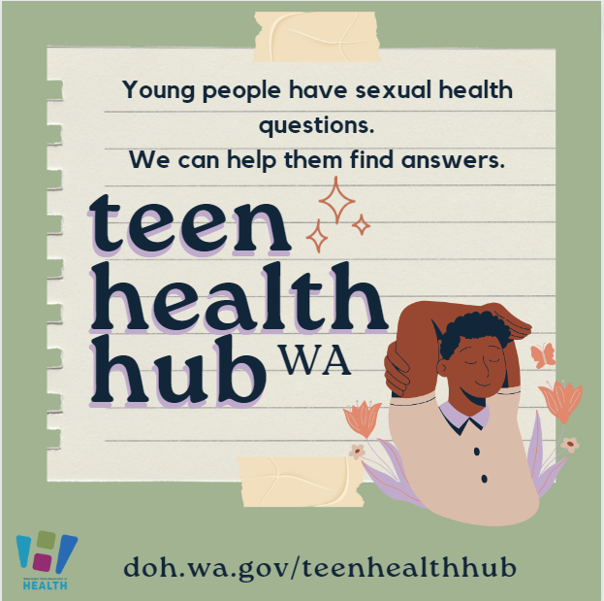
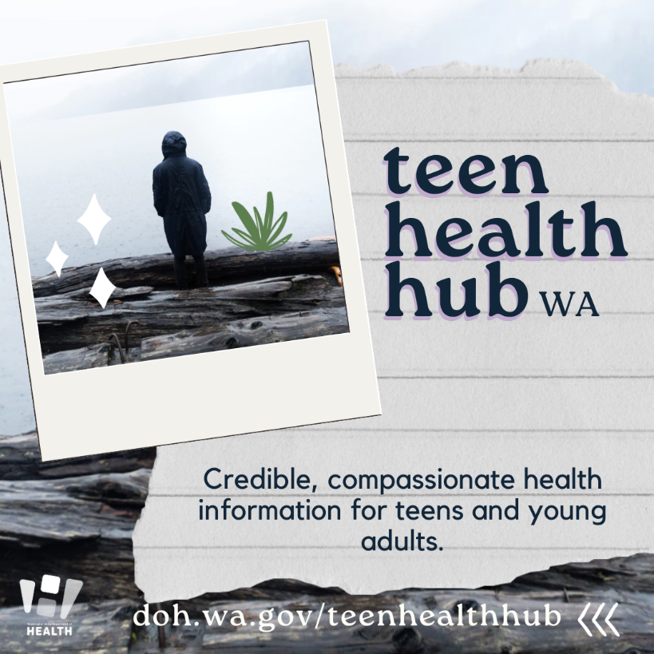 | 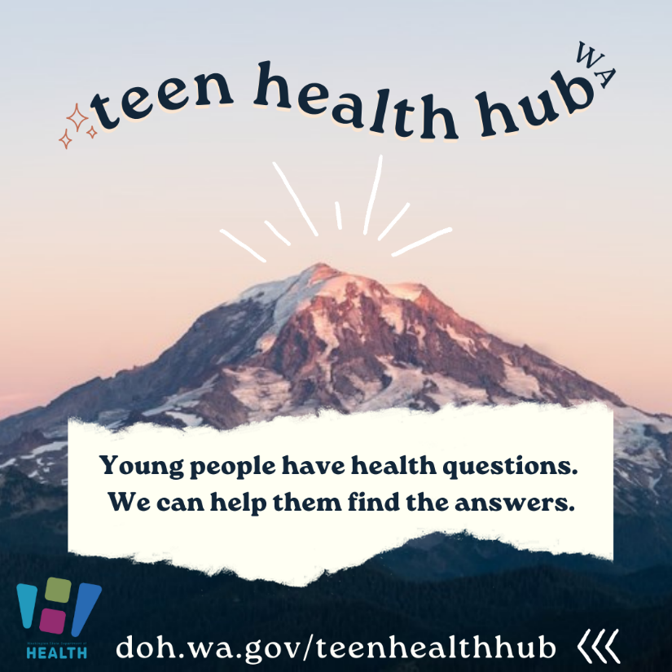

To request this document and/or the images in another format, call 1-800-525-0127. Deaf or hard of hearing customers, please call 711 (Washington Relay) or email civil.rights@doh.wa.gov.

