Insert Coalition Logo HERE

Medication Lock Box Post -Survey

In order to ensure that prescription medication is being taken only by those it is prescribed to, it is important to lock up medication in a secure container at home. The [insert name of coalition], in partnership with the Washington State Health Care Authority, Division of Behavioral Health and Recovery, provided local residents lock boxes for this purpose. Please answer the following questions about your use of the lock box by circling your response.

- At what location did you receive your lock box?
[Insert list of lock box distribution / pick up sites in your community]

______________________________ ______________________________

______________________________ ______________________________

______________________________ ______________________________

- Please rate your level of awareness about safe storage of prescription drugs.

(Circle one)
1 | 2 | 3 | 4 | 5  (highly aware)
(Not aware at all) (Highly aware)

- Are you currently locking up your medication? Yes or No

- Are you currently using your lock box to lock up your medication? Yes or No

IMPORTANT: If you have expired or unused medication, make sure to dispose of it at one of the secure disposal sites listed here: [list secure disposal site locations]. Do not throw away or flush unused medication.

For questions or concerns, please contact [insert coalition contact name] by phone at [insert coalition contact phone number] or via email at [insert coalition contact email address]. For more information about the [insert coalition name] please visit us at Facebook.com/ [insert Facebook page]

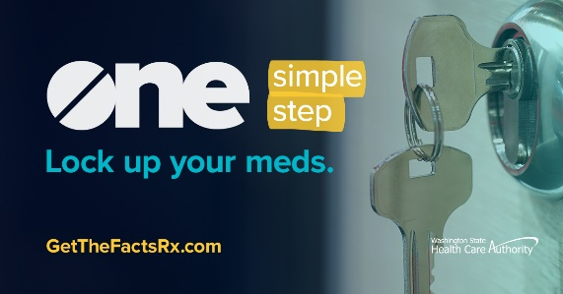
Thank you for taking this important step to keep your family and community safe !

