National Overdose Awareness Day Content

newsletter copy
Each year on August 31st, National Overdose Awareness Day is observed to remember the lives taken by overdoses, without stigma or shame. Overdose death is preventable. Everyone can take simple steps to prevent opioid misuse and keep your loved ones safe.

This Overdose Awareness Day, remind your communities that 75 percent of opioid misuse starts with people using medication that wasn’t prescribed for them—usually taken from a friend or family member. Locking up medications or safely disposing of unused medications can stop them from being misused. People can protect their loved ones by finding a medication take-back program near them at https://med-project.org/locations/washington/

For more resources about how to communicate about this topic in your community, visit https://getthefactsrx.com/

Post 1: safe storage/safe disposal
Suggested post date: August 30
August 31st is #NationalOverdoseAwarenessDay. Simple steps, like safely disposing of unused medications, can prevent opioids from being misused. Protect your loved ones – find a safe medication return kiosk near you at a pharmacy near you https://med-project.org/locations/washington/
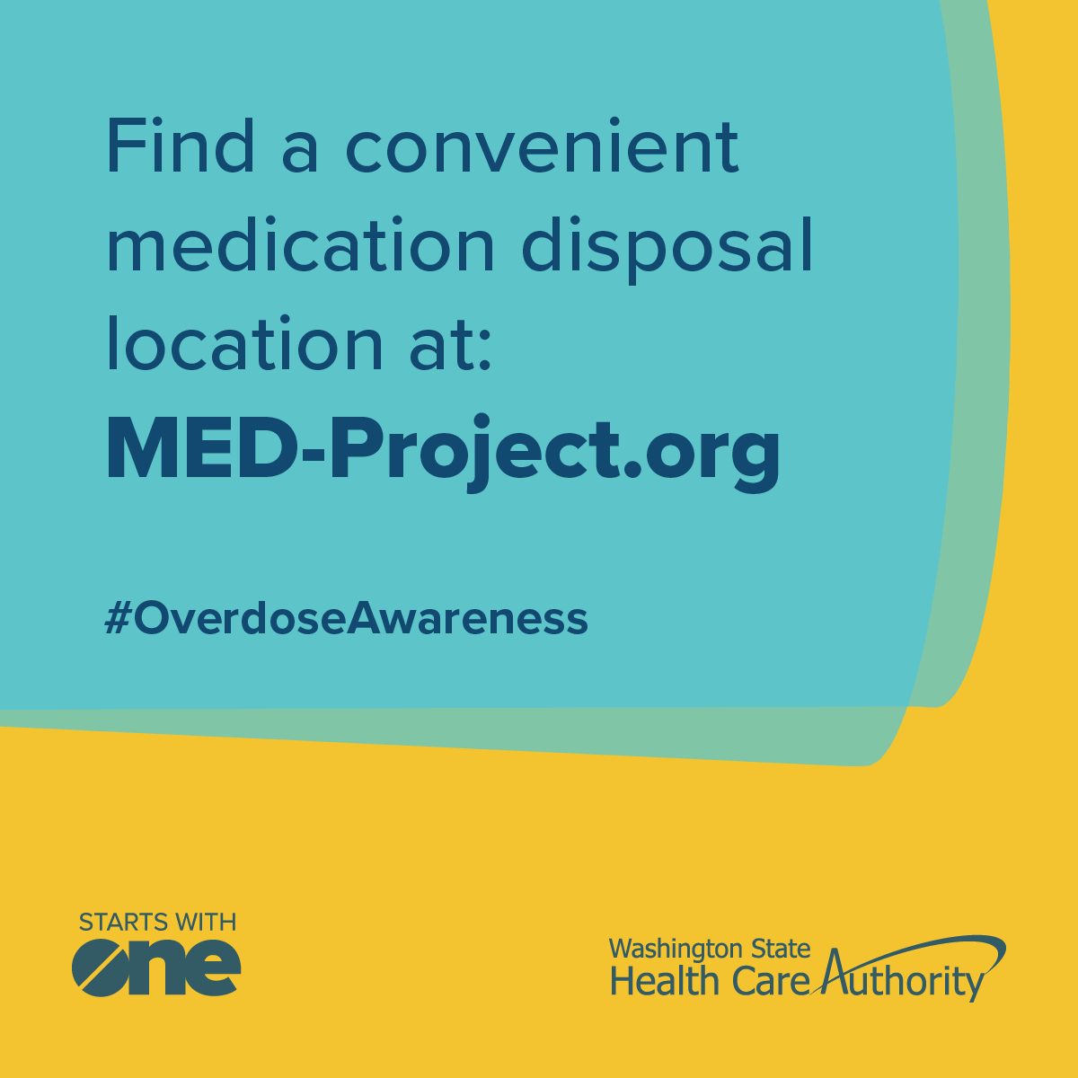

Post 2: Signs of an overdose
Suggested post date: August 31
Knowing the signs of an opioid overdose could save a life. Below are some key symptoms to look for. If you detect any signs of an overdose, call 911.
Learn more at https://stopoverdose.org/basics/learn-about-opioid-overdose/
#NationalOverdoseAwarenessDay
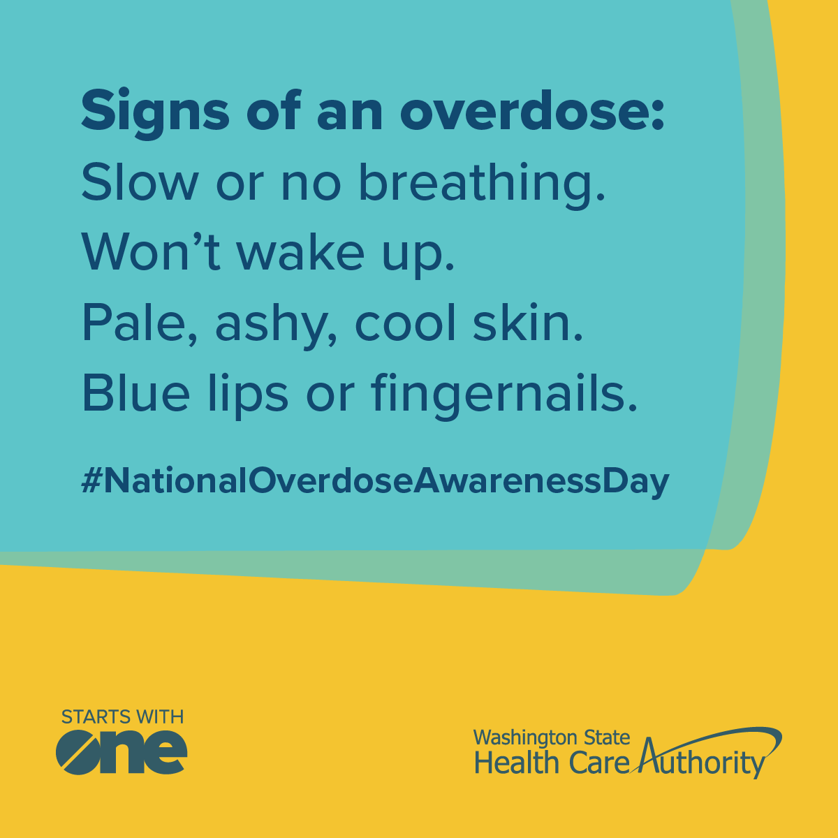

Post 3: Naloxone
Suggested post date: September 1
Did you know that Naloxone reverses an opioid overdose? Naloxone is a prescription medicine that can be easily and safely administered by anyone, and helps a person begin breathing again and wake up from an overdose. In Washington state, individuals can order free naloxone online and have it delivered directly to their home. This #NationalOverdoseAwarenessDay, take the step of ordering naloxone – it could save a life.
Order naloxone here: https://stopoverdose.org/find-naloxone-near-me-washington-state/
