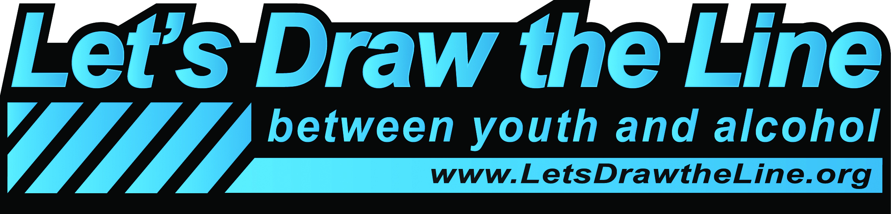

Let’s Draw the Line Between Youth and Alcohol - 2013

Initial Registration Form

Project Contact person:
Phone number:
Email address:
Name of group that will carry out the project:
Mailing address (including city and zip code):
County in which the activity will occur:

If applicable:
Name of the fiscal agent you will use:
If your community group is not eligible to accept LDTL funds from Washington State’s Department of Social and Health Services, please note the name of the organization or entity that would receive LDTL funds on the behalf of your group.

Return your completed form to: LDTL2013@dshs.wa.gov. Unless otherwise noted, all e-mail correspondence, including reporting requirements, are to be sent to: LDTL2013@dshs.wa.gov. For phone inquiries, call Ray Horodowicz at: (360) 725-1528.

