2026 Community Survey Data Entry Instructions
Welcome to the Washington State Health Care Authority (HCA) Division of Behavioral Health and Recovery (DBHR) Community Survey!
This document provides instructions for entering paper-based Community Survey responses into ServiceNow (SNOW). These instructions apply to surveys administered in the following languages: English, Cambodian/Khmer, Chinese, Russian, Somali, Spanish, and Vietnamese.

Important paper vs. online difference (Questions 11-12 only)
Paper surveys and the online ServiceNow survey collect the same information, but they appear in a slightly different format. These differences are expected and do not affect data quality when responses are entered correctly. Questions 11 (11a and 11b) and 12 (12a and 12b) are displayed differently:
- One the paper survey, responses for Middle School (6th–8th grade) and High School (9th–12th grade) appear side by side.
- In ServiceNow, these same questions are shown one after the other, first for Middle School (6th–8th grade) followed by the High School (9th–12th grade). Although they appear as separate questions online, they correspond directly to the side-by-side columns on the paper survey.
Paper Survey (Question 11): Side-by-side
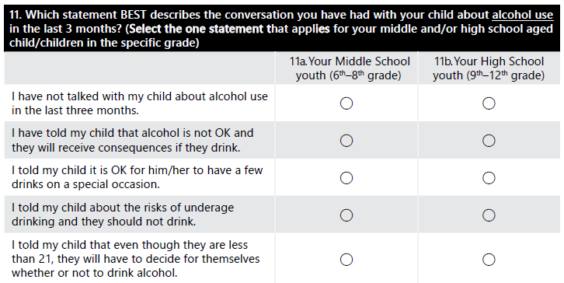
ServiceNow Survey (Question 11): Side-by-side
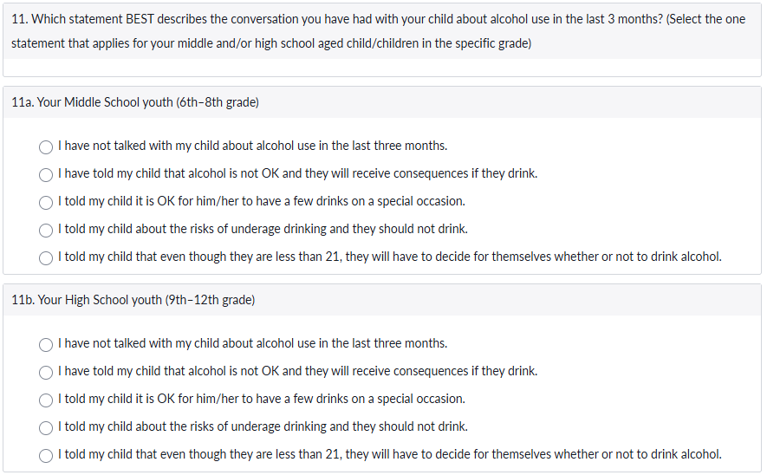
Enter responses into the question labeled for the correct grade level. If the respondent answered for only one grade level, enter data only for that grade and leave the other blank. Do not duplicate responses across grade levels unless both are selected on the paper survey.

How to enter data from paper into ServiceNow
Follow the steps below for each paper survey:
Step 1: Open
Access the participant-facing or public survey link
Step 2: Enter Survey Responses
- Enter responses exactly as marked on the paper survey.
- Select the ServiceNow response option that exactly matches the participant’s selection.
- If a question was left blank on the paper survey, leave it blank in ServiceNow.
- Do not infer or guess responses.
Surveys in languages other than English: All paper survey versions share the same layout. If you are entering data from a non-English survey and are unsure of the response order, refer to the English paper survey to confirm the correct response option sequence.
Step 3: Submit
Select the “Submit” button to record the responses.
Each paper survey should be entered once. It is recommended to enter data as soon as possible after collection to reduce errors. If you are unsure whether a survey has already been entered, pause and verify before proceeding.

Questions
If you have questions about data entry or encounter issues, contact your HCA Prevention Manager.

