Excel-based Logic Model template and application of SPF
Presented by South Southwest PTTC 1.28.2026
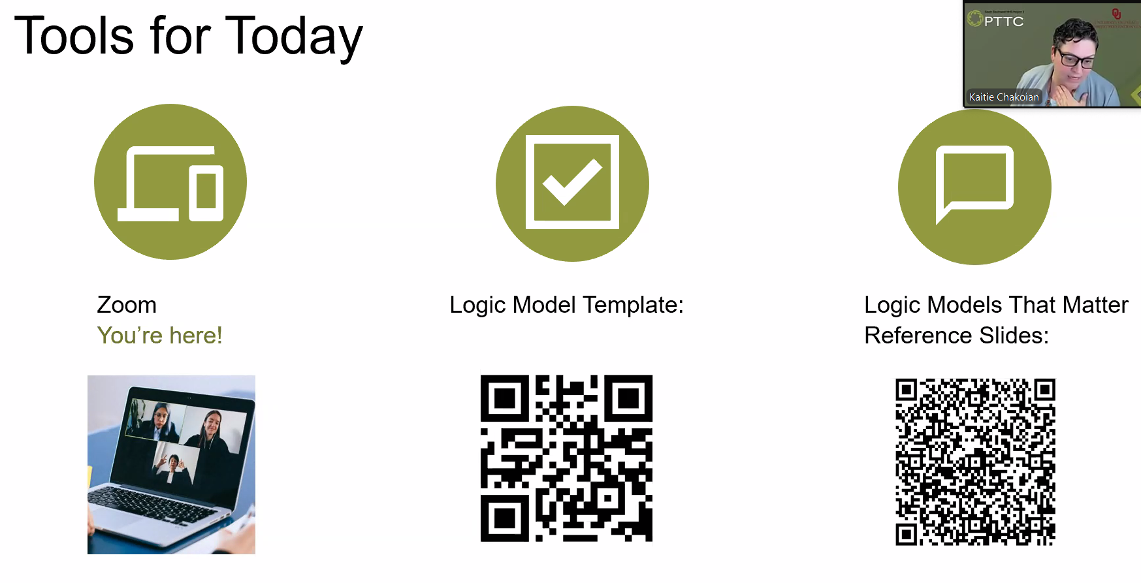
Training Links:
- Links to Tools: Develop an Effective Program Logic Model Technical Assistance and Training - Prevention Technology Transfer Center (PTTC) Network
- Data Reference Slides: Logic Models That Matter: Reference Slides - Google Slides
- Resources for RPFs: Risk/Protective Factors - Prevention Technology Transfer Center (PTTC) Network
- Sample Action Plans: https://pttcnetwork.org/sampl-action-plans/
Summary Takeaways and Thoughts:
- South SW PTTC recommends using the excel logic model template BEFORE the writing of any strategic plan narratives or action plans - I agree
  - They frame this logic model template as the “map for decision making” during strategic/action planning
- Potential Benefits for providers: The excel document can be an extremely beneficial tool to incorporate into our strategic planning cycle
  - Breaks down various strategic planning components into clear chunks
  - Provides a framework that many narrative components of the full strategic plan can be referenced
  - Reframes/clarifies some of the confusing terms in our current logic model that folks seem to get stuck on
  - Components can be mapped onto our current logic model
- Potential Benefits for PSMs: Primary benefit as a progress and early “problem” identification tool
  - Help ensure needs assessment and data informing other key components of strategic planning are on the right track during the development/writing of strategic plan narrative
  - Tool for early PSM identification of problems to avoid large revisions and editing needed during the strategic plan review period
  - Potential for early identification and referral to Intensive TA services throughout planning cycle
- Additional Notes:
  - Does not replace our current logic model – I do like the “clean” overall look of the current logic model compared to the very detailed look of the excel template
  - Would require some tailoring to our system to ensure that our core requirements are reflected in the base template

Using the Excel Logic Model Template:
- Assessment tab and start inputting and organizing your data.
  - Start with Problem & Related Behaviors
    - Name the problem -> list the specific indicator -> List the indicator source
  - Identify Risk/Protective Factors, their indicators and source of data
- R&P LM w Outcomes Tab - explore program/strategies and thinking about outcomes
  - Link problem behavior, R&P Factors to Evidence-Based Interventions (Strategies/Programs)
  - Identify general short-term and long-term outcomes
- Evaluation Tab – deep dive into outcomes
  - Take a data driven approach to outcomes evaluation
  - Delve deeper into short- and long-term outcomes
- Outcomes Logic Model Tab – Summary page putting (most) everything together on one page
- Evaluation Tab – based on identified outcomes
  - Identify how and where evaluation data will be collected, assessed, etc.

There was a question on Local Conditions – which are not directly included in the provided template
- Use the data and examine what may be the root cause of the blend of the problems/related behaviors and RPFs
- Think of them as a deeper layer informing what is increasing (risk factor) and decreasing (protective factor) risk in the community
- These may be variables that are even more visible and specific within a community not necessarily directly included in the research of R/P factors but contributing to them

Identifying outcomes: Remember, outcomes should directly tie to the behavior you are looking to address
- Short-Term Outcomes (Change in Knowledge/Attitudes/Skills): Immediate effects, such as increased awareness, improved knowledge about the risks of substance use, changes in attitudes, or increased skills in resisting peer pressure.
  - AKA Intervention results from pre/post data
- Intermediate Outcomes (Change in Behavior/Context): Changes in behaviors and environmental factors, such as increased adoption of school policies, increased perception of harm, or reduced access to substances.
  - Are your risk and protective factors being influenced in the ways you expect
- Long-Term Outcomes (Directly related to identified problem): Sustained changes, such as reduced rates of substance misuse, lower underage drinking rates, and improved overall community health.
  - Are your problem behaviors changing in the anticipated direction, recognizing this takes TIME
  - These can look like changes in conditions, policies, organizational structures

Recommend the logic model comes BEFORE the strategic plan writing (the strategic plan is a beefy action plan) – frame the logic model as a “map for decision making”

Breakout Room Peer Share Notes:
- A little easier for someone not tech savvy than Word templates
- I was paired with coalition leaders and they agreed that this was a good data layout – recommended multiple sets of eyes look at things –
- This layout REALLY helps to tell the story, anyone looking at it can read and understand each of the tabs
Q& A Notes
Make this your own – add additional rows and columns if there is information/data that is missing

KK and AC initial thoughts on the Excel Logic Model
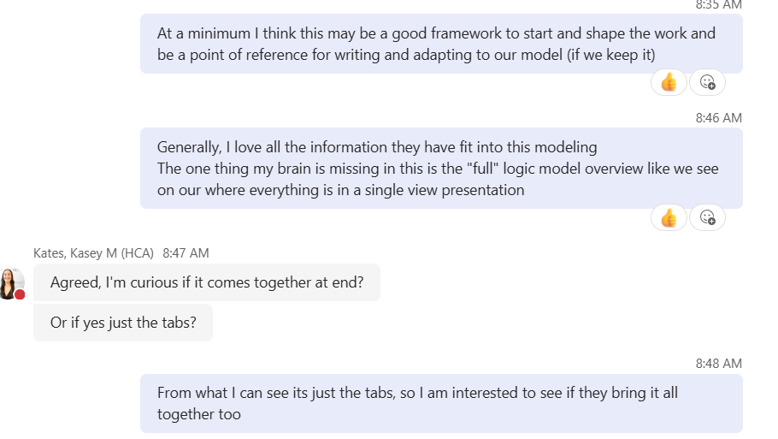
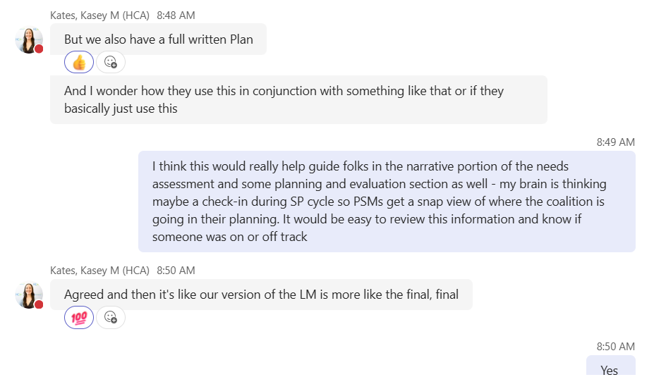
Followup - Outcomes LM is the “bringing it all together” logic model

