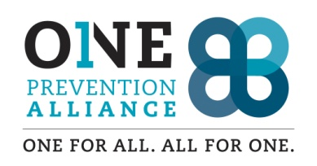

**Volunteer Background Check & Permission From**

I hereby allow One Prevention Alliance (OPA) and/or Skamania County Sheriff’s Office to perform a check of my background including:

* Washington State Patrol Check
* Employment and Volunteer History
* Personal references and other persons or sources as appropriate for the volunteer position in which I have expressed an interest.

I understand that I am not required to agree to this background check, but refusal to do so may exclude me from consideration for some types of volunteer positions and that all such information collected during the check will be kept confidential.

I hereby also extend my permission to those individuals or organizations contracted for the purpose of this background check to give their full and honest evaluation of my suitability for the described volunteer work and other such information, as they deem appropriate.

Signed: Date: