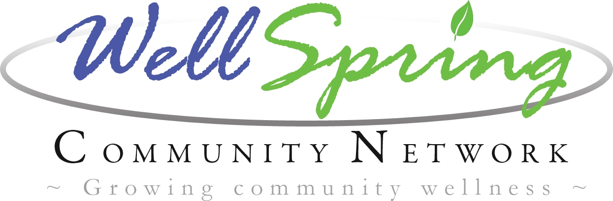

Drug Free Communities Grant
Coordinator Position – Full Time Position
General Responsibilities:
Coordinate services for the WellSpring Community Network’s Drug Free Communities Grant

Essential Functions:
- Provide leadership support for all WellSpring Community Network Coalition meetings, steering committee meetings, and ad hoc committee meetings.
- Supervise the Administrative Assistant in developing meeting agendas, meeting notices, recordkeeping and other administrative duties.
- Ensure all DFC grant record keeping and recording requirements are met.
- Facilitate the Drug Free Communities strategic work plan as described in the grant document such as developing community partnerships; recruiting new coalition members; coordinating community Town hall Meetings and other coalition events, partnering with volunteers, youth , schools, youth serving organizations and other community based stakeholders.
- Provide leadership in planning and coordinating community and school based education and awareness events, media campaigns, and community/parent outreach.
- Work closely with Capacity Building Team in securing in-kind donations, and identifying and pursuing local funding opportunities from individuals, service clubs, businesses and foundations.
- Make presentations about the mission and work of the WellSpring coalition to service clubs and other community groups.
- Provide environmental strategies and or strategic prevention framework training to coalition members.
- Mandatory attendance at required DFC trainings.
- Serve as a key liaison between WellSpring Community Network and the general public, service providers, boards and interested parties.
- Development of reports, documents, brochures, newsletters.
- Leverage resources for sustainability of the DFCG and the WellSpring Community Network: research, identify, and prepare applications to obtain funding for various projects, studies, or programs. Develop and administer programs as needed.
- Develop and maintain a record-keeping system that provides for the proper evaluation, control and documentation of assigned operations. Prepare and submit timely reports, budget and financial operations, and projects and resource development in line with Network goals and in compliance with the DFCG.
- Maintain and manage the Network’s office, record keeping and business functions for public accountability, and ensure reporting legal obligations are met.
- Establish and maintain effective working relationships with other coalition board, staff, service providers, contractors, public officials, the general public, and representatives of other agencies.

Minimum Qualifications:
- Bachelor’s degree in Education, Social Services or closely related field required. A minimum of two years education in closely related field combined with five years experience in community coalition building and prevention practices can be substituted for Bachelors Degree requirement. Preference will be given to candidates with knowledge in youth substance use prevention, youth prevention programs, prevention principles and experience in coalition building, community mobilization and outreach
- Working knowledge of Microsoft Office software applications including; Excel, Word, Publisher, etc. Must have exceptional interpersonal relations skills, strong organizational skills and the ability to create and maintain community partnerships.
- Ability to communicate effectively both orally and in writing and ability to make effective public presentations on technical, complex, and often, controversial information.

Preferred Qualifications and Skills
- Thorough knowledge of planning principles, practices, and techniques as they relate to human services and community development, with special emphasis on programs and services for at-risk youth and families.
- Strong operational skills in data collection and analysis, and grant-writing skills.
- Knowledge and practices of budget development, grant acquisition, and administration.
- Working knowledge of application and interpretation of federal, state and local rules, regulations, codes and ordinances as they relate to area of assignment.
- Experience working with youth and school programs.
- Working knowledge of principles and techniques of program evaluation and monitoring.

Employment Requirements
- Ability to independently initiate, plan and complete work assignments
- May be assigned to work on both long and short-term projects and have more than one project assignment at any given time.
- Appear for scheduled work with regular, reliable and punctual attendance.
- Establish and maintain cooperative, effective, and productive working relationships using tact, patience and courtesy.
- Effectively plan and organize work and complete tasks within prescribed timeframes.

Travel required, reimbursed within travel budget. Use of personal vehicle, valid Washington State Drivers License and Auto Insurance required.

Successful completion of drug test, criminal records and fingerprint background check.
- Ability to lift and carry supplies and/or equipment weighing up to 50 pounds.
Employment Information:
Location: Long Beach, Washington
Assignment: Full time, 37.5 hours per week
Salary Range: $40,000 per year plus benefits

