Generating specific fact sheets using AskHYS.net
www.askhys.net
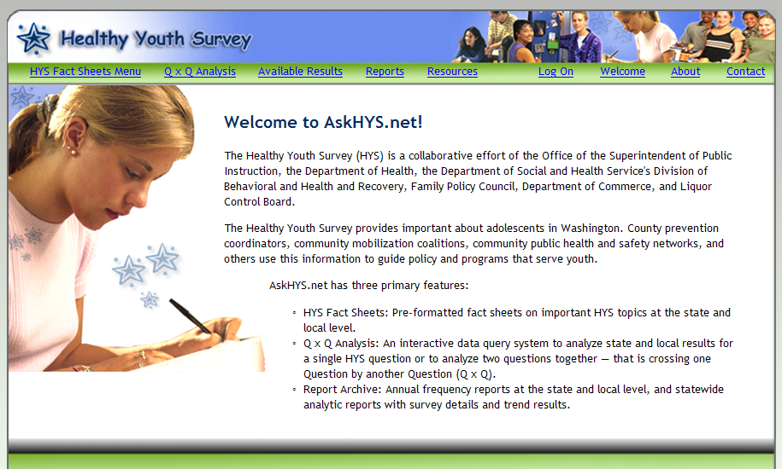
Click on HYS Fact Sheets Menu
This will take you to a page on which you can designate the specific content you want in a two-page fact sheet.
If you have permission from the school district, you can generate reports down to the individual building level. If not, you can only generate reports from the county, ESD or state level.

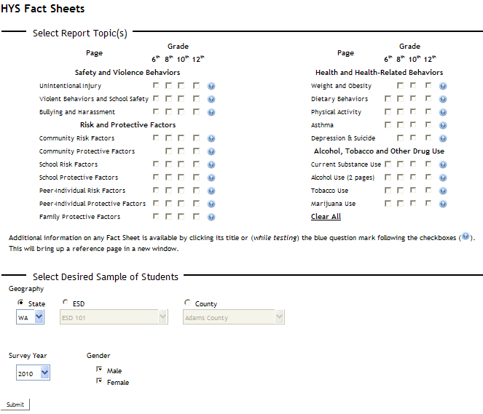
Basic process for setting up fact sheets. The alcohol use fact sheets are two-pages. All others are one page.
1 – Choose the specific variables you want included in fact sheet. For instance, if you wanted to look at alcohol use by 6th graders you would select that button.
2 – Choose a geography. With permission from the school district you can generate school building level or school district results. Without permission, you can only generate county, ESD, or state-level reports.
3 – Choose which survey year you want – if you choose 2010 the fact sheet will provide you with the trends back to 2002.
4 – Choose if you’re interested in looking at males or females or both.
5 – Click submit. It will take a few minutes to generate, but then you’ll have a two-page fact sheet on every variable you selected in “A,” above.

The following page contains a graphic from the AskHYS alcohol fact sheet and is roughly the way I would recommend laying out the one-page briefing sheet to hand out to prospective coalition members. It’s even better if you can have Vancouver School District or Discovery Middle School numbers instead of Clark County numbers.
We can do better for our kids!
Clark County roughly mirrors the state alcohol usage rates with 15 out of every 100 8th grade students reporting drinking a full beer or its equivalent within the past month. But that’s not good enough. With concerted community action, those rates can be driven down and the result for youth is increased academic performance, increased health, and decreased violence, involvement in the criminal justice and healthcare systems.
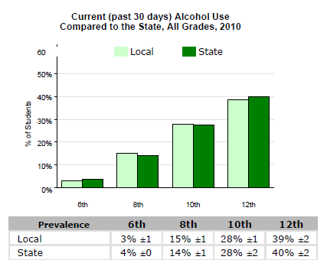
Source: Washington State Healthy Youth Survey, 2010
- Statewide, 44% of 8th graders who drink alcohol report getting lower grades in school (C's, D's or F's) compared to those who don't drink (26%).
- Alcohol is implicated in nearly a third of youth traffic fatalities. Alcohol can affect the developing adolescent brain. Most kids find it easy to get alcohol from friends, at parties, or from home.
- We’re meeting to discuss what we can do about this on ________ (date), _________ (time), at _______________ (location).
Can you please attend and give us your ideas about how we bring these rates down so we can ensure brighter futures for our kids?
Questions? Contact Tiffany Schwieterman, __________ (phone), __________ (email).

