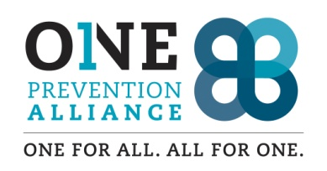

Coalition Involvement Agreement (CIA)

|  |  |  |
| --- | --- | --- |
| Sector | Member Name | Organization |
|  |  |  |

This agreement between One Prevention Alliance Coalition (OPA) and the Representative shall be from until terminated by mutual accord. This agreement will be reevaluated on a yearly basis.

OPA will be responsible to:

1. Create and follow by-laws and policies.
2. Formulate coalition goals and objectives
3. Oversee operations of activities and programs.
4. Continue to increase new membership of the coalition.
5. Create and follow a strategic Action Plan
6. Create a credible and relevant sustainability plan which includes volunteer membership and resources, both financial and material.
7. Respects the rights of OPA members to hold their own opinions and beliefs.

The Representative, will be held to:

1. Be a community leader amongst the represented sector.
2. Ensure clear communication between the sector represented and the coalition.
3. Act as a positive role model for youth, families, and peers.
4. Support the coalition’s mission.
5. Attend coalition meetings which are held on a monthly basis on the 1st Tuesday.
6. Participate in at least one subcommittee.
7. Attend coalition sponsored trainings, town hall meetings, and community events.
8. Contribute to the strategic planning process.
9. Participate in sustaining the coalition’s capacity, involvement, and energy.
10. Prevent youth substance abuse through environmental strategies.

|  |  |
| --- | --- |
| Coalition Rep’s Name | Sector Rep’s Name |
| Coalition Rep’s Signature | Sector Rep’s Signature |
| Title/Date | Title/Date |