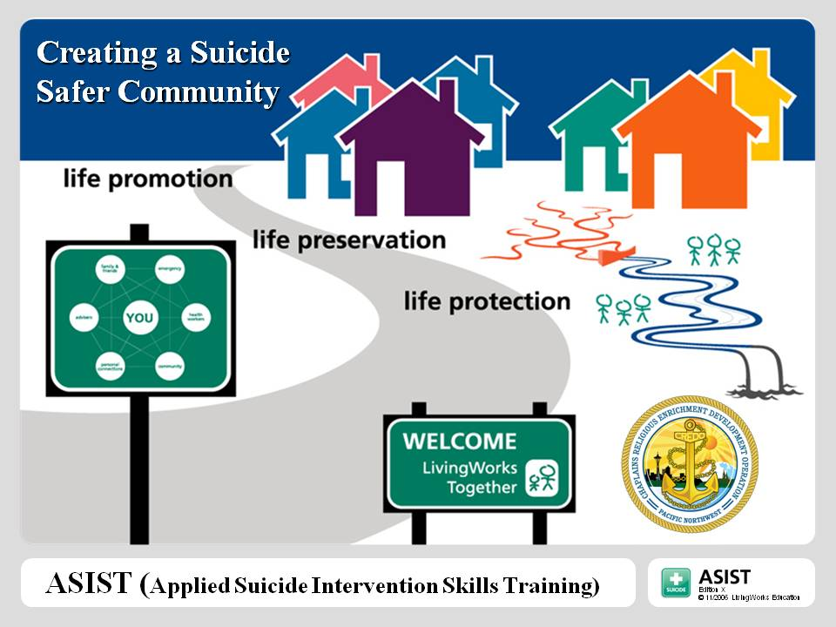
LEARN SUICIDE FIRST-AID SKILLS
November 18-19, 2013
8:00 am – 4:30 pm

Faith Lutheran Church
382 W Cedar Street
Sequim, WA 98382


APPLIED SUICIDE INTERVENTION
SKILLS TRAINING
(ASIST)

Learn to be a more willing, capable and confident care giver to those having thoughts of suicide. For
a variety of reasons, people often find themselves having thoughts of suicide. These people are in the
“river of suicide”. We need lifeguards trained in suicide first-aid who can help get them out of the
river and linked to the appropriate resources. ASIST teaches suicide first-aid intervention skills.
Over the course of the two-day workshop (15 training hours) you will learn specific skills that help
you identify those at risk and how to better listen to and care for those having thoughts of suicide.
The workshop is open to all. Target audience is anyone who may come into contact with someone
having thoughts of suicide.

Registration is $65 if received by November 8, 2013. Registration after November 8th is $80. Seating is limited to 30 so register early. Mandatory 2-day participation. Continental breakfast and lunch will be served.

Make check or purchase order payable to: Prevention Works!

Only if using purchase order, please e-mail registration and purchase order to Jennifer Charles at smile98362@msn.com.

Mail to: Prevention Works!
PO Box 1913
Port Angeles, WA 98362

Questions? Contact Leeann Grasseth at 360-562-7297 or e-mail jdgrasseth@aol.com.

Sponsored by: Prevention Works! A Community Coalition of Clallam County

-----------------------------------------------------------------------------------------------------------------------------------------------------------------------

APPLIED SUICIDE INTERVENTION SKILLS TRAINING
Registration Form (one form per registrant)

Name:

Agency or Organization (if applicable):

Address:

City, State & Zip:

Phone: Fax: E-mail:

Amount Enclosed: $65 $80 Purchase Order

Please include fee or purchase order with registration.
No confirmations will be sent.
You will be notified if the training is full and no spaces are available.

