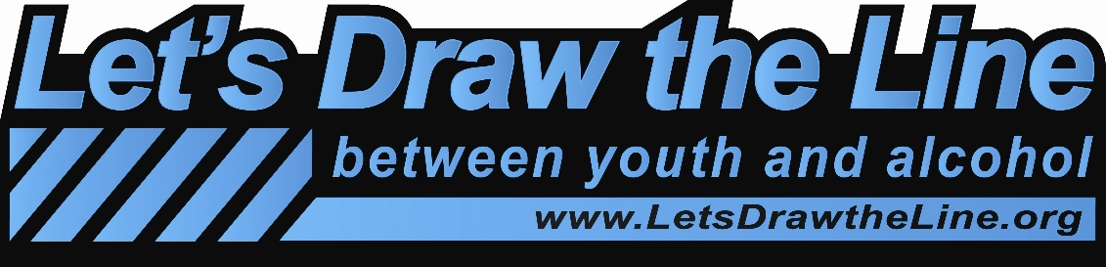
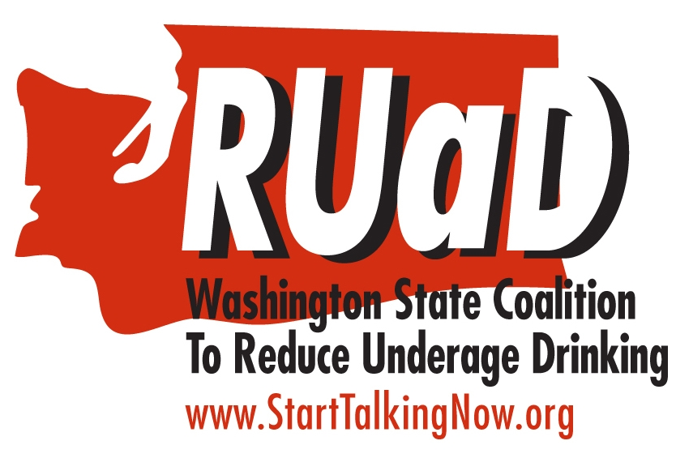

Project 1 Description
Law Enforcement Draws the Line Between Youth and Alcohol
Engage your police department, sheriff’s department, and State patrol in speaking out about the importance of adults not providing alcohol to minors and the benefits of youth not drinking.
Hold an event that focuses on enforcing underage drinking laws. The event should:
- Involve law enforcement and/or the prosecutor’s office and judicial representatives in the planning and presentation of your event.
- Explain the consequences of underage drinking, including arrest and disposition, and record (juvenile and adult) information;
- Include a press release to the media (example on www.starttalkingnow.org); and,
- Invite participants to sign Hero Cards.
- Take photos of 6 or more law enforcement officials holding Let’s Draw the Line Between Youth and Alcohol signs in the presence of local community residents, especially youth. Post the photos on the Let’s Draw the Line Facebook page.
- Have a minimum of 10 law enforcement officials complete Hero Cards.
- Place law enforcement PSA on radio reminding the public of the importance of not providing alcohol to minors.
Legislators Draws the Line Between Youth and Alcohol
Let your legislators know about the prevention work you are doing.
- Meet with at least 2 of your 3 state legislators (Tips on Contacting Your Legislators on www.starttalkingnow.org.)
- Describe the Let’s Draw the Line campaign and the importance of not providing alcohol to minors;
- Describe other prevention efforts you are involved in.
- Take photo of each legislator holding a Let’s Draw the Line Between Youth and Alcohol sign and post on the Let’s Draw the Line Facebook page.
- Have each legislator you meet with sign a Hero Card.
Approval of your stipend will be based on completion of all the items above. In addition, Project 1 requires 100 completed Hero cards from your community. The Hero Cards from law enforcement and legislators can count toward this goal. Hero Cards from Project 2 or Project 3 do not count toward the Project 1 goal.

Project 1: Grant Agreement and Final Report Form
Your Name: Phone Number:
Organization: Email Address:
County or Tribe: Date:
Number of people involved in the planning and implementation of this project:
Number of youth Number of adults
Law Enforcement Draws the Line Between Youth and Alcohol
- Event
- Date, time, location of event:
- Targeted population invited:
- Number of attendees:
- Attach agenda
- Attach press release
Name of speaker(s) | Organization or sector  they represent | Topic they discussed

- Photos of 6 or more law enforcement officials holding Let’s Draw the Line 11”x17” signs. Post photos on the Let’s Draw the Line Facebook page.
Name | Title
- Hero Cards
- Scan 100 or more Hero Cards to RUaD
- Separate out and mark the Hero Cards from Law Enforcement
- Radio PSA
- Attach radio text and name of speaker(s)
- Attach information on: the number of times the spot ran; over what period of days or weeks did the spot run; and what it would cost to run those spots if they were paid for.
- Attach an audio file of the radio PSA to the Let’s Draw The Line Facebook page.
Legislators Draw the Line between Youth and Alcohol
- Meet with your legislators about Let’s Draw the Line Between Youth and Alcohol
Name of Legislator | # of Legislative District | Check if photo posted on Facebook | Check if Hero Card was sent to RUaD
(Forget the district number? Look it up at: http://apps.leg.wa.gov/DistrictFinder/Default.aspx)
- Photos
- Attach a photo of each legislator holding Let’s Draw the Line 11”x17” sign (preferably with your local community members with the legislator).
- Post photos on Let’s Draw the Line Facebook page.
Signature from organization that the project was implemented and completed.
Vendor's Certificate: I hereby certify under penalty of perjury that the items and totals listed herein are proper charges for materials, merchandise or services furnished and/or services rendered have been provided without discriminations because of age, sex, marital status, race creed, color, national origin, religion, or Vietnam era or disabled veterans status.
Signature

To receive your award of $1,000 for this project:
- Scan the following and send as email attachments:
- Event Agenda
- Copy of media coverage
- Photos of 6 or more law enforcement officials
- 100 Hero Cards, including Law Enforcement and Legislators Cards
- Radio PSA with value of estimated match
- Legislators’ photos
- Final report form with signature.
- Scan and return your required materials (identified above) to earlyse.swift@dshs.wa.gov.
- When this form is completed and the materials identified above are submitted we will send you your $1,000 award for this project.
DBHR signature accepting project as completed

