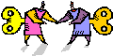
Let’s get to know each other and have some fun!
11.5 Things About Me…


11.5

