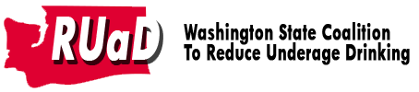

Sample letter to editors: Reducing youth exposure to alcohol messages

As parents, we know that our children’s well-being and future are in our hands. Our decisions, actions and attitudes shape the home environment they grow up in.

Most of us are also aware that no matter what we do to provide the best home environment for our children, they will also be impacted by the environment outside the home - the community environment. While most communities have many positive elements, such as good schools and safe places to play, there are unhealthy influences as well, that we have the power to change.

In most communities children are exposed to alcohol promotions every day. This continuous presence of alcohol ads on billboards, stores, and at community festivals and sporting events gives children the message that drinking alcohol is a necessary part of having fun and growing up. Research shows that children as young as five are as familiar with alcohol slogans and mascots as they are with popular cartoon characters.

The good news is that Washington has laws restricting outdoor advertising of alcohol. Stores can have no more than four signs on their building advertising alcohol brand names and manufacturers. The size of these signs must be no more than 1,600 square inches. Ads cannot be within 500 feet of schools, places of worship, playgrounds or athletic fields.

As parents and community members, we can increase the odds that our kids will stay alcohol-free by preventing their access to alcohol, limiting their exposure to alcohol ads, and teaching them about the ways advertising can influence their decisions. The simple act of asking kids questions about alcohol advertising and alcohol use in movies makes them more skeptical about the “benefits” of alcohol.

To learn more about how you can reduce underage drinking, visit www.StartTalkingNow.org.

