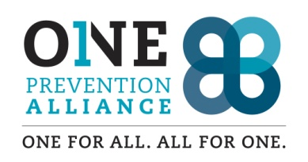

**Volunteer Agreement**

**Agency**

We, One Prevention Alliance (OPA) and/or Skamania County Sheriff’s Office agree to accept the services of beginning .

And we commit to:

1. Provide accurate information, training and assistance.
2. Ensure supervision and provide job assessment and feedback.
3. Respect the skills and individual needs of the volunteer.
4. Respect the right of volunteers to their own opinions and beliefs.

**Volunteer**

I, , agree to serve as a volunteer and commit to:

1. Perform volunteer duties to the best of my ability.
2. Follow agency rules, policies, and procedures, including recordkeeping requirements and confidentiality.
3. Meet time and duty commitments or to provide adequate notice so that alternate arrangements can be made.

**Agreed to:**

Volunteer Printed Name/Signature Date

OPA Staff Representative Printed Name/Signature Date