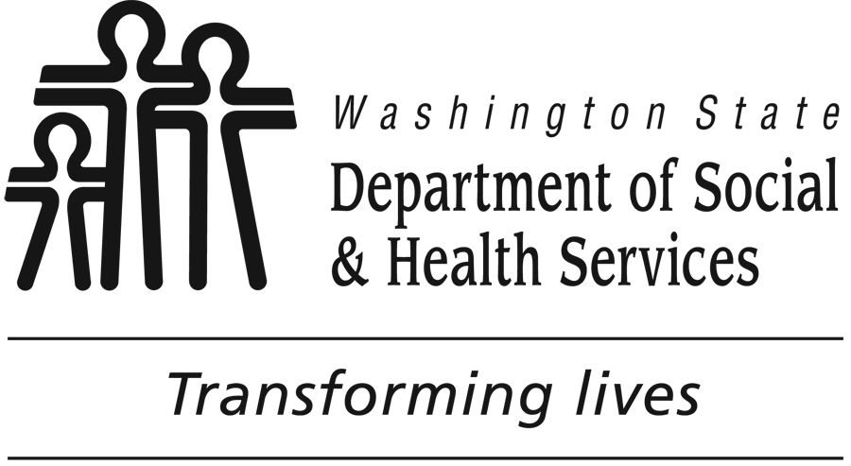
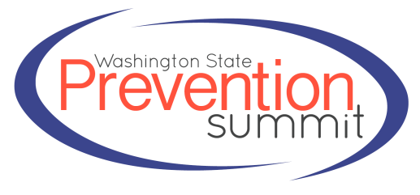
2014
Washington State
Exemplary
Substance Abuse
Prevention Awards

Sponsored by the Washington State Department of Social and Health Services’ Division of Behavioral Health and Recovery in cooperation with the Office of Superintendent of Public Instruction, Washington State Department of Health, Washington Traffic Safety Commission, Washington State Liquor Control Board, and Prevention Specialist Certification Board of Washington.

Overview

Goals
The goals of the Washington State Exemplary Substance Abuse Prevention Awards are to:
- Recognize outstanding community partners and youth engaged in substance abuse prevention efforts.
- Focus statewide attention on exceptional substance abuse prevention work.
- Identify exemplary evidence-based substance abuse prevention programs with exceptional outcomes that can be adopted or adapted by others.

2014 Timeline
July 29, 2014 Announcement and nomination packet distributed
September 10 by 5:00 p.m. Deadline for nomination submission
September 30, 2014 Notify awardees
October 20, 2014 Awards Ceremony, Washington State Prevention Summit, Yakima, Washington

Application Procedures
Nominations may be submitted via email, postal mail, or fax. The Nomination Application begins on page 4 of this packet. Keep in mind that the review committee will have only the information that you provide to assess the nominee’s suitability for an award. Nominations with missing or otherwise incomplete information will not be successful. Attachments with supporting information will not be reviewed.

Categories
- Youth Leadership – group or individual
- Prevention Professional
- Community Coalition – with emphasis on substance abuse prevention
- Sector Representative
- Program – demonstrating exemplary outcomes
Criteria for Awards

- Exemplary Substance Abuse Prevention Youth Leadership:
To be considered for the award, nominees must be strong prevention advocates who demonstrate good peer leadership, teamwork, and volunteerism. Nominees must have regularly participated in community and/or school prevention activities for a minimum of one year.

- Exemplary Substance Abuse Prevention:
To be considered for the award, nominated individuals, departments, coalitions, organizations, businesses, or agencies must be strong prevention advocates. Nominators should demonstrate the nominee’s leadership and community partnerships for evidence-based prevention service delivery, community involvement in relation to the community coalition’s strategic plan, and their commitment to substance abuse prevention.

Exemplary Substance Abuse Prevention Program: (one nomination will be selected from this category)

To be considered for the award, program nominations must address all elements in question two (2), page five (5) to substantiate the following:
  - Be in operation for a minimum of one year.
  - Be focused on evidence-based substance abuse prevention. Programs that include both prevention and treatment must clearly detail the prevention component. Expected outcomes or areas of focus should include, but are not limited to, decreasing high-risk use of alcohol and drugs by adults; eliminating use of illicit drugs; preventing alcohol, tobacco, and other drug use; and reducing experimentation by young people. Program does not have to be listed as a nationally recognized Evidence-Based Practice; however it must have evidence-based research to support its goals and outcomes.
  - Describe the evaluation plan and how outcome data is applied to improve program design and implementation.
  - Document and demonstrate success in the form of outcome data obtained through verifiable processes.
  - Describe how the program design has considered each of the Center for Substance Abuse Prevention’s (CSAP) Principles of Substance Abuse Prevention in the appropriate domain. A list of the CSAP Principles is available on The Athena Forum website at: http://theathenaforum.org/sites/default/files/CSAP_Principles_of_SA_Prevention.pdf.

Selection Process
A review committee, including representatives from the Division of Behavioral Health and Recovery (DBHR), Office of Superintendent of Public Instruction, Washington State Department of Health, Washington Traffic Safety Commission, Washington State Liquor Control Board, and the Prevention Specialist Certification Board of Washington, will conduct a selection process. Reviewers will evaluate and select nominations based on the stated criteria and information provided. Every attempt will be made to ensure that awardees represent a range of demographic, ethnic, cultural, and geographic areas.

Benefits of the Substance Abuse Prevention Exemplary Awards
Awardees will be honored on October 20th at the 2014 State Prevention Summit in Yakima, Washington. The awards will recognize the efforts of dedicated individuals, successful programs, and supportive organizations; celebrate their successes; and share their strategies with others in the field. Additional benefits may include local recognition and a greater ability to market programs, recruit volunteers, and/or leverage other resources to support their work. Programs that seem suited to the rigorous national standards will be encouraged to apply for the national awards.

Past Exemplary Awardees 2010-2013

Note: Previous Exemplary Award winners may be nominated again after four (4) years if they are able to demonstrate new efforts in prevention, or a significant program expansion, enhancement, or improvement. A list of past awardees is included below.

Health Care Sector: Gary Schillhammer, MD., Darrington (2012).
Law Enforcement Sector: Sheriff Frank Rogers, Omak (2012).
Religious or Fraternal Organization Sector: Pastor David Curtis, Wellspring (2012).
School-based Sector: Gerald Apple, Shelton (2012).
Parent Sector: Cathy Schindler (2013).
Youth-Serving Organization Sector: Vicky Marques (2013).
Business Sector: Dwight & Janie Ballestrasse (2013).
Local or Tribal Government Sector: King County Board of Health Subcommittee on Secure Medicine Return (2013).
Program/ Strategy: Mercer Island Social Host Ordinance, Mercer Island (2012).
Community Coalition Coordinator: Anna Marie Dufault, Yakima (2012); Kelly Matlock, Jefferson County (2012); and Anne Dean, Jefferson County (2012); Inga Manskopf, Seattle (2013).
Substance Abuse Prevention Community Coalition: Okanogan County Community Coalition, Omak (2012); Reardan-Edwall Communities Alliance for Prevention (RECAP) (2013).
Youth Leadership Award: Kent Police Youth Board, Kent (2010); Shelton High School SADD Club, Shelton (2011); Breanna Atwell, Shelton High School (2012); Quincy Youth Action, Quincy (2012); and Wenatchee Youth Coalition, Wenatchee (2012); Katie Albaugh, Shelton High School (2013); SHEO, Dayton High School (2013).
Volunteer Award: Shelly Mitchell (2010); and Christine Mackleit, Spokane (2011).
Collaborative Award: Castle Rock Police Department, Castle Rock (2011).
Professional: Sharon Foster, Olympia (2011).
Youth Volunteer Award: White Swan Dream Makers Youth Group, White Swan Community Coalition (2010).
Youth Project Award: Washington Drug Free Youth Program, Greater Spokane Substance Abuse Council (2010).
Lifetime Achievement: Julie Grevstad (2010); Gene Uno (2010); Florence Bucierka (2011); Patricia Mouton (2011); Terry Reid (2011); Col . Jerry Kosierowski, Washington National Guard (2012); Mary Ellen de la Peña, Kitsap County (2012); Ramona Leber (2013); Carol Owens (2013).

Nomination Submission

Nominations must be received by 5:00 p.m. Wednesday, September 10, 2014.

If you have any questions please contact:
Kristin Murphy, PREP Coordinator at 360.725.3753 or murphkh@dshs.wa.gov

To Submit Your Completed Nomination Application
- Email: attach completed form via email and send to: murphkh@dshs.wa.gov
- Mail: DBHR, ATTN: Kristin Murphy, PO Box 45330, Olympia, WA 98504-5330
- Fax: 360.725.2280; ATTN: Kristin Murphy, PREP Project Coordinator, DBHR

AWARD NOMINATION APPLICATION

Nominations must be received by 5:00 p.m. Wednesday, September 10, 2014.

Name of Nominee:
Program Name: (if applicable)
Agency or Organization: (if applicable)
Nominee Mailing Address: City: , WA Zip Code:
Nominee Telephone: Email:

Person submitting this nomination:
Name: Agency: How do you know the Nominee?
Office Telephone: Cell Phone: Email:
Mailing Address: City: , WA Zip Code:
Do you want the Award committee to contact the nominee regarding the results of the nomination?
Yes, please contact them. No, I will contact them myself.

List two references that can substantiate the information you have provided: (Required)
- Name: Email address: Telephone number:

- Name: Email address: Telephone number:

Award Categories
Select ONE category that best describes the nominee.

** Please review the selection criteria described on page 2 of this packet **

☐ Youth Leadership – individual or group
☐ Prevention Professional (for example: substance abuse prevention coalition coordinator, county prevention staff, school-based prevention/intervention specialist, ESD prevention manager, prevention program/project coordinator, state agency partner)
☐ Community Coalition (with emphasis on substance abuse prevention)
☐ Coalition Sector Representation – Indicate one sector the nominee represents:
☐ Business ☐ Religious or Fraternal organization
☐ Civic/Volunteer group ☐ School
☐ Healthcare professional ☐ State/Local/Tribal Government
☐ Law enforcement ☐ Youth-serving organization
☐ Media ☐ Youth
☐ Parent ☐ Other substance abuse prevention organization
☐ Chemical dependency treatment ☐ Mental health services representative
☐ Program (Demonstrating Exemplary Outcomes)
Award Nomination Narrative
Answers are rated on a scale of 0-4 points; scores are competitive within respective categories.
0 points = No information provided.
1 point = Answer lacks clear evidence of substance abuse prevention efforts.
2 points = Answer shows some steps in the right direction by nominee.
3 points = Answer shows good substance abuse prevention effort from the nominee.
4 points = Answer clearly demonstrated that the nominee is exemplary, going above and beyond or exceeding expectations in the substance abuse prevention field.

The best nominations will completely answer each question, provide specific examples, and include information in each answer that shows how the nominee’s work is exemplary among their peers. Keep in mind that the review committee will have only the information that you provide to assess the nominee’s suitability for an award. Nominations with missing or otherwise incomplete information will not be successful. Attachments with supporting information will not be reviewed.

1). Explain why or how the NOMINEE (individual, group, organization, or agency) is exemplary in each of the following questions. NOTE: If the nominee is a program skip to question 2.
    - How long the nominee has been contributing to prevention?
    - Describe their substance abuse prevention activities:
    - How does their substance abuse prevention work set them apart from their peers working in prevention?
    - How does the nominee make efforts to better serve under-served populations?
    - How does the nominee demonstrate cultural competency?
    - Explain how the nominee is involved with the community or school in substance abuse prevention efforts? (Provide examples of outstanding contribution or commitment.)
    - How has the nominee faced or overcome special challenges to achieve their goals?
    - What has the nominee done to show that they are a leader in substance abuse prevention?
    - Provide examples of strong partnerships that have been developed and how that has enhanced the substance abuse prevention efforts.
    - Any additional information: (optional).

2). If nominating a PROGRAM, answer the following (please review evaluation criteria for Programs on page 2):
  - How long has the program been in existence?
  - What are the program’s goal(s), objective(s), and target audience?
  - What are the findings of substance abuse prevention program’s outcome-based evaluations?
  - How the program has incorporated science-based prevention theory, such as the Risk and Protective Factor Model and Principles of Substance Abuse Prevention, into activities?
  - What success has the program had with volunteers or in-kind contributions?
  - Outline the program’s evaluation plan (i.e., outcomes expected, tools, and timelines to measure success, process for improvement based on outcomes, etc.).
  - How is collaboration and community involvement incorporated into the program’s work?
  - How has the program involved multiple local community sectors and the target audience in assessment, planning, implementation, and evaluation?
  - Any additional information: (optional).

Thank you for submitting the nomination!

