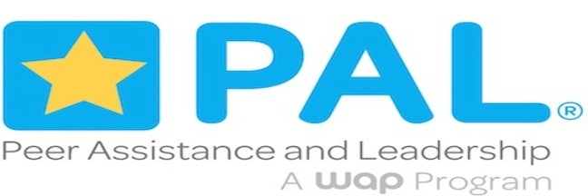

Scope and Sequence

We developed this suggested scope and sequence as a resource to help PAL® teachers balance the training curriculum in order to achieve the optimum benefit to the students. It is intended to supplement the PAL® Teacher Manual. You’ll recall that the Training section of the manual is separated into eight different components (each separated by purple tabs). What follows is a possible way to sequence these components so that everything is addressed while not being monotonous (you’ll also recall that it is not advised to think of the eight components as topics that should be covered in the order in which they are listed). Many of the training sections include suggested activities; these activities are sequenced to provide a spiraling level of skills development.

A few important notes before you start:
1) Along with each of the training components are listed suggested topics to be addressed. For more information about what we mean with each of these, you can look in the Teacher Manual, where you’ll find each of these topics as subsections within the training components.
2) This suggested scope and sequence is based upon a traditional 60 minute, 5 day week training period. In any accelerated or block scheduling programs, the material will be covered in approximately one-half the time.
3) Refer to the “additional resources” lists and the manual, and feel free to call our offices for assistance. Also, remember that training is meant to be an ongoing process throughout the year through guest speakers, skill building seminars, and processing sessions.

Objective: To balance the curriculum contents so students get what they need to feel successful in their roles as peer helpers.

First 6 weeks of school is the initial student training period.

Week 1:
- Component: Program Orientation
  - Topics: Getting Acquainted, Program History, Role of Peer Helper, Confidentiality
- Component: Group Dynamics
  - Topics: Establishing Group Norms, Group Building
- Component: Self Awareness
  - Activities: My Coat of Arms, Forced Choice
- Component: Understanding Behavior
  - Topics: The Nature of People
- Component: Communicating, Listening, and Facilitating
  - Topics: Setting the Tone, Non-verbal communication

Week 2
- Component: Program Orientation
  - Topics: Characteristics of a Peer Helper, Limitations
- Component: Group Dynamics,
  - Topics: Group Building, Group Characteristics
- Component: Self Awareness
  - Activities: Wheel, Dear Me Letter, Self Awareness exercise
- Component: Understanding Behavior
  - Topics: Influences on our Behavior, Causes of Misbehavior
- Component: Communicating, Listening, and Facilitating
  - Topics: Active Listening, Facilitative Responses
- Component: Decision-Making and Problem-Solving
  - Topics: Getting Started, Strategies for Decision Making

Week 3
- Component: Group Dynamics
  - Topics: Group Building, Group Characteristics
- Component: Self Awareness
  - Activities: Who Holds Me Up, Circlegram
- Component: Understanding Behavior
  - Topics: Bringing It All Together
- Component: Communicating, Listening, and Facilitating
  - Topics: Active Listening, Facilitative Responses, Bringing It All Together
- Component: Decision Making and Problem Solving
  - Topics: Factors Influencing Decisions, Group Decision Making
- Component: Knowledge of Referral Resources
  - Topics: Knowing When to Refer, Developing a Referral Resource Directory
- Component: Other Issues and Topics
  - Topics: Substance Abuse Prevention

Week 4
- Component: Group Dynamics
  - Topics: Group Building, Group Characteristics
- Component: Communicating, Listening, and Facilitating
  - Topics: Facilitative Responses, Foundations of a Helping Relationship
- Component: Decision Making and Problem Solving
  - Topics: Group Decision Making, Action Planning
- Component: Knowledge of Referral Resources
  - Topics: Involving Referral Resources in Training, Reminders on Limits
- Component: Other Issues and Topics
  - Topics: Substance Abuse Prevention, Multiculturalism

Week 5
- Component: Communicating, Listening, and Facilitating
  - Topics: Stages in the Helping Process
- Component: Knowledge of Referral Resources
  - Topics: Involving Referral Resources in Training (Guest Speakers!)
- Component: Other Issues and topics
  - Topics: Substance Abuse Prevention, Multiculturalism

Week 6
- Prepare to Deploy
- Review essential elements and logistical details
- Make and discuss referral assignments
- Check students’ comfort level of skills development and do additional activities as necessary

Weeks 7- End of school year: service learning/working with PAL®ees.

