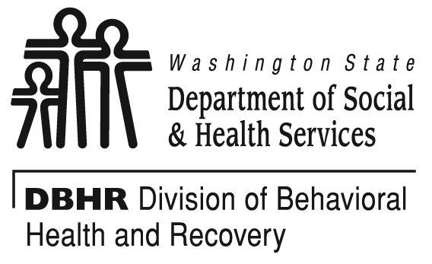

PRI News Release Template

Purpose and procedures for news release template:
- The purpose of the news release is to notify your community that they have been selected as a designated PRI site, and to encourage community members to get involved in your coalition.
- You may add any local data and quotes you wish
- Please do not edit the DBHR director’s quote.
- Issue your news release by April 1, 2011.
- Send a copy of your final news release, and copies of any news coverage, to your DBHR contact.
=================================================================================

Date:
Your County Contact Name and Phone Number:
Your County/ Program:

(Community name) designated a substance abuse prevention site

(Your City)- (Your Community) has been selected to receive support to focus on keeping youth, young adults and others free of alcohol and other drug misuse, while creating a healthier community. The support, which includes funding for training, technical assistance, and community and school-based prevention programs, is from the state Department of Social and Health Services’ Division of Behavioral Health and Recovery (DBHR).
(Coalition name) will begin services (add date your services will begin, or “no later than July 1, 2011”) and invites community members to be involved with planning and implementing programs.
(Your Community) is one of 19 communities statewide funded by DBHR’s Prevention Redesign Initiative (PRI) to develop new coalitions or support existing ones. DBHR is supporting this Initiative in order to focus community and school-based prevention resources in the same targeted communities across the state, increasing opportunities to see community-wide changes to drug prevalence rates and associated consequences.
(Sample Quote: “A number of factors were considered in selecting (name of community) for services”, said (county spokesperson). “These included (list your factors) along with the community’s readiness to benefit from these services”.
The Coalitions will be represented by parents/grandparents, youth, healthcare professionals, educators, law enforcement, faith leaders, civic/volunteer groups, government, substance abuse prevention and treatment organizations, business, media, schools and youth-serving organizations.
To achieve the primary goal of reducing underage drinking and the related negative consequences such as juvenile crime, the community coalitions will identify the highest prevention needs, plan and implement evidence-based strategies, leverage local resources and evaluate the impact of selected programs.
“Our goal in redesigning and targeting our state prevention services is to leverage enough resources in the highest-need communities to achieve greater reductions in substance abuse and the harm it causes”, said David Dickinson, DBHR’s Director. “Community leaders are prepared to use these resources to help more young people succeed, and to improve the health and safety of their community” added Dickinson.
PRI communities will focus on reducing underage drinking among 8th and 10th graders, improving academic performance, and reducing juvenile crime. DBHR will expand PRI in the next three years to identify approximately 50 high need communities in Washington State.
State and county data from the 2010 Washington State Healthy Youth Survey will be released in March and available online. Tips for parents for preventing underage drinking can be found at www.StartTalkingNow.org.

To find out how to get involved with the (name) coalition, contact__________.

