What do we mean by Adverse Childhood Experiences?
10 categories of experience up to 18 years old
childhood abuse
- emotional,
- physical, or
- sexual
childhood neglect
- emotional, or
- physical
growing up with:
- domestic violence
- substance abuse (alcohol or drugs)
- mental illness
- parental discord
- crime

What is The ACE Study?
The ACE Study is ongoing collaborative research between:
The Centers for Disease Control and Prevention in Atlanta, GA, and
Kaiser Permanente in San Diego, CA.
The Co-principal Investigators:
Robert F. Anda, MD, MS, with the CDC; and
Vincent J. Felitti, MD, with Kaiser Permanente.
Over 17,000 Kaiser patients participating in routine health screening volunteered to participate in The Study. Data resulting from their has revealed staggering proof of the health, social, and economic risks that result from childhood trauma.

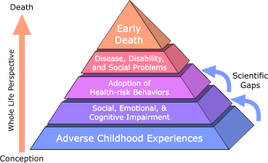
The ACE Pyramid
This represents the conceptual framework for the study. During the time period of the 1980s and early 1990s information about risk factors for disease had been widely researched and merged into public education and prevention programs. The ACE Study was designed to assess what we considered to be “scientific gaps” about the origins of risk factors.
These gaps are depicted as the two arrows linking Adverse Childhood Experiences to risk factors that lead to the health and social consequences higher up the pyramid.

High numbers of adverse childhood experiences are predictive of problem behaviors related to the work of DBHR.

